Historical Background of the Farmstead on Which the Log Stable Originally Stood
Joan Berkey, architectural historian
January 2025

According to a 2017 dendrochronology study, the log stable was built “in or shortly after the calendar year 1783, apparently in 1784 or perhaps as late as 1785.” It originally stood on a 200+-acre farmstead located on the north side of the Cohansey River in lower Hopewell Township, Cumberland County, New Jersey. Although the area is known as Dutch Neck, no Dutchman is known to have settled here. The farmstead originally consisted of two tracts—one of 163 acres and the other of 40 adjoining acres—purchased in March 1696 by Jonathan Holmes (ca. 1668-1712) from the estate of John Barkstead [fig. 1]. The legal description in the deed noted that the acreage was located on the “northside of the Chohansey [sic] in the forks of Kiewhaps Creek, along the Turtle Branch.”
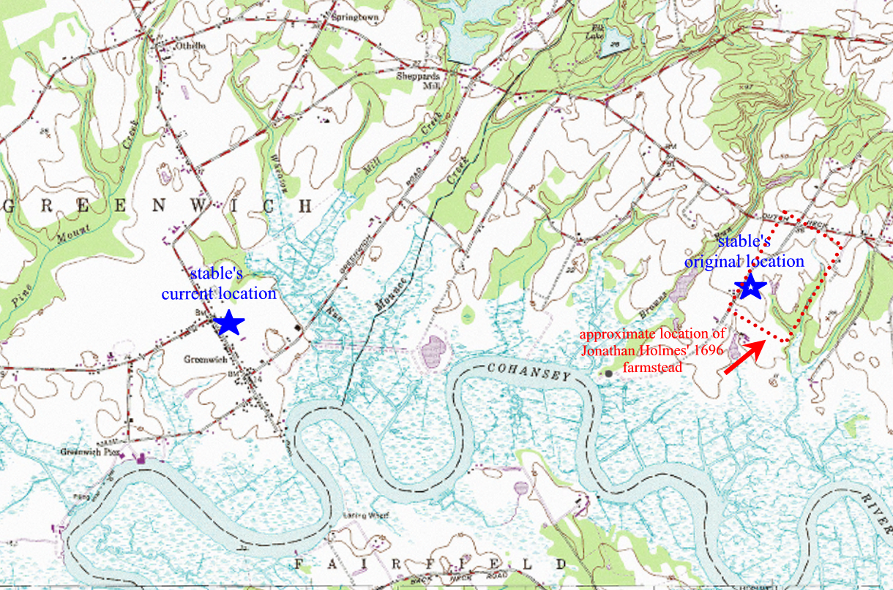

Figure 1: USGS map annotated to show the location of Jonathan Holmes' 1696 farmstead, the original location of the log stable, and the present location of the log stable in the village of Greenwich. The distance between the two, measured in a straight line, is about 2.5 miles. North is represented by the top of the image.

Hopewell Township, then as now, was overwhelmingly agricultural in nature and consisted of 100- to 300-acre farms established by English-speaking settlers beginning in the 1680s. The choicest farmsteads were those, like Holmes’, located on the fertile lands along both sides of the Cohansey River.

Jonathan Holmes was the grandson of Obediah Holmes Sr., (1606-1682) who immigrated from Lancashire, England in 1639 and settled in Salem, Massachusetts. Obediah’s son and Jonathan Holmes’ father, Obediah Holmes Jr. (ca. 1650-1723), settled first in Middletown, Monmouth County, New Jersey, then moved to the newly-established village of Greenwich, Cumberland County, about 1685. At the time, Cumberland County was still part of Salem County until it separated into its own county in 1748. This migration pattern—from England to New England in the early 1600s, then to Long Island, New York and northern New Jersey in the mid-1600s, and finally to southern New Jersey in the late 1600s—was typical for English-speaking settlers in the 17th and 18th centuries.

Jonathan Holmes’ will of September 15, 1715 gave his son, Jonathan Jr. (ca. 1705-1778), the “house and plantation I now live on.” His inventory, merely itemized, noted that he owned “catel” [sic], horses and sheep which were valued at £70 (half of the total inventory), and that his wheat was worth £2. At the time, Jonathan Jr. was still a minor and little is known about his life as an adult. He is cited as a juror in the 1750s and is listed in the 1770s tax lists as a resident of Hopewell Township. Jonathan Jr. died in 1778 and was interred in the old burying ground at the Presbyterian Church in Greenwich. No will or inventory was filed for him and the farm was inherited by his only son, Abijah (1741-1785).

It was likely during Abijah Holmes’ ownership that the log stable was built between 1783-1785. Abijah was a veteran of the Revolutionary War, having served as a lieutenant colonel in the Second Battalion of the Cumberland County militia. He was also a justice of the peace in 1776. Holmes died in 1785 and willed his farmstead equally to his two sons, John (1778-1855) and Ephraim (ca. 1780-1848), both of whom were minors at the time of his death. The post-mortem inventory taken of Abijah’s personal estate included such farm-related items as cattle, horses, hogs, and sheep in addition to wheat and hay, some of which were likely housed or stored in the log stable. He also owned wagons, a sleigh, and “plantation utensils” along with two “Negro slaves.” Holmes had advertised a $20 reward for the return of a “mulatto boy” who ran away from him in 1778. The census of 1790 showed 120 enslaved people lived in Cumberland County, the lowest number in all of the state’s 13 counties that year and a number that represented about 1% of the state’s total of 11,423 enslaved residents. In that census, Cumberland County had a total population of 8,248 people. It is not known what role, if any, Holmes’ enslaved people played in building, working in, or possibly even residing in the log stable.

In 1801, the Orphan’s Court ordered a division of the land that John and Ephraim inherited from their father. John received 102 acres located on the southeast side of present-day Loatman Road, a tract that included the land on which the log stable stood. He also received a nearby 33-acre meadow tract and his brother, Ephraim received 180 acres located east of John’s tracts. A map showing the division was filed with the Surrogate’s Office, but it unfortunately did not delineate buildings nor were any buildings mentioned as reference points in the legal descriptions.

John Holmes is enumerated in the 1830 census as residing in Hopewell Township with his second wife, Phoebe (nee Ireland), two daughters, and three sons. He and his wife are between the ages of 50 and 60. In 1834, Hopewell Township was described as having one Seventh-Day Baptist church, one Methodist church, four stores, five run of stones for grinding grain, one rolling and slitting mill, three tanneries, one cupola furnace, and two cider distilleries. In 1830, its population was 1,953.

In the 1840 census, he is enumerated with his wife, four sons, and one daughter. Of the males enumerated, two were employed in agriculture, no doubt John and one of his sons. In 1844, Hopewell Township was described:

Hopewell is 11 m. long by 4 in breadth,--and is bounded N. by Upper Alloways Creek, Salem co., S by Fairfield, E. by Fairfield and Deerfield, and W. by Greenwich and Stow creek. The Cohansey forms its eastern and southern boundary line. The surface is slightly rolling,--the soil, a clay loam. The township contains 5 stores, 1 forge, 1 flouring-m[ill], 2 grist-m[ills]; 12 schools, 973 scholars Pop. 2,220.

Curiously, John and his family were not enumerated in the 1850 census, the first census to provide names, occupations, and specific ages for each member of the household. John died in 1855 without a will and the local newspaper noted his passing with a simple death notice: “DIED: At his residence in Hopewell Township on the 26th inst., JOHN HOLMES SR., in the 77th year of his age.”

The post-mortem inventory of his personal estate, taken June 19, 1855, shows he owned household goods that were typical of the mid-19th century and included carpet, tinware, earthenware, Windsor chairs (6), blankets (18), quilts (11), a map of the United States, and numerous beds. He owned no livestock, but farming-related items included a fan mill [windmill], a plow and cultivators, a watering trough, and grain cradles.

That fall, the John Holmes’ farm was sold at auction. The sale, advertised in the local paper [fig. 2], noted that the farm consisted of 165 acres of upland, meadow, and plowed land “in a high state of cultivation” in addition to “woodland composed of chestnut, oak and hickory.” The farm was enclosed with “a good fence of cedar and chestnut rails.” The buildings were described as a house that was “a good frame two storys [sic] front, and cellar under, with kitchen, sitting and bedrooms adjoining,” in addition to a “large wagon house with cellar that will hold 2000 bushels of potatoes,” and “out stables for young stock, sheep, &c.,” the latter likely describing the log stable.

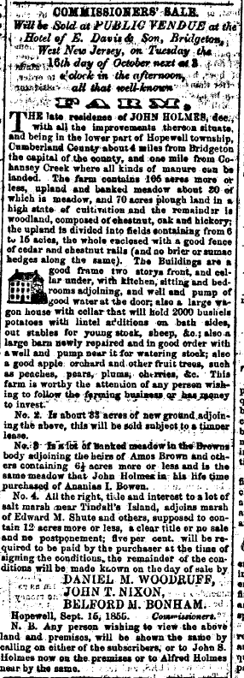

Figure 2: The advertisement for the auction of the John Holmes farm. [West-Jersey Pioneer (Bridgeton, NJ), 9-29-1855, 4]

The farm was purchased by Holmes’ son, Alfred (1814-1893), who was already living on the farm according to the auction advertisement (noted at the bottom of fig. 2) and was presumably farming the property. Alfred purchased tracts #1 and #2, the first consisting of 74.5 acres and the second consisting of a nearby parcel of 33 acres, paying $10,320 for them. When plotted, the first tract of 74.5 acres corresponds with present-day block 89, lots 5 and 5.01 in Hopewell Township and is the land on which the log stable stood; the second tract of 33 acres corresponds with block 89, lot 10 [fig. 3].
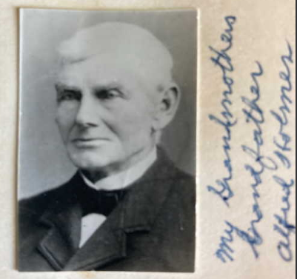
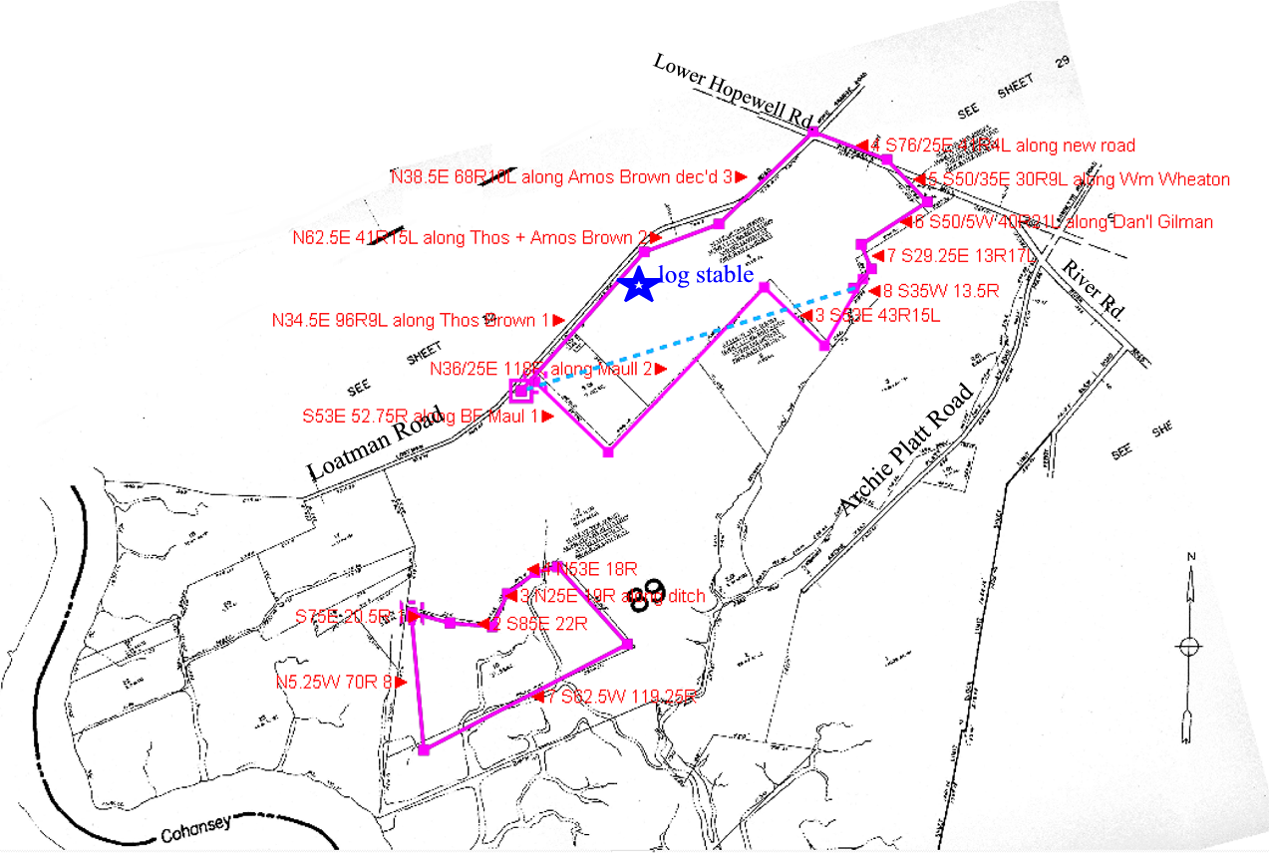
Figure 3: current tax map with the outlines (in pink) showing the boundaries of the two parcels that Alfred Holmes bought in 1855.

Figure 4: ca. 1880 photograph of Alfred Holmes.
[https://www.ancestry.com/mediaui-viewer/collection/1030/tree/74603979/person/48297585193/media/76d45a92-1d6e-4e8e-bb13-07334e68652d?src=search]

Alfred Holmes [fig. 4] is enumerated in the 1860 census as a 46-year old farmer, living in the house with his wife, Elizabeth (nee Lupton), and seven children. He claimed real estate valued at $10,000 and a personal estate valued at $2,000. Tragedy struck the family when their son, Moses Bloomfield Holmes (1838-1864), was killed as a Union soldier fighting in the Battle of Cold Harbor in Virginia on June 4, 1864.

In the 1870 census, Alfred is a 55-year old farmer with real estate valued at $15,000 and is enumerated with his wife, four daughters, a laborer, and an apprentice. The 1876 Beers map [fig 5] shows him as the owner of a 100-acre farm on the east side of present-day Loatman Road in lower Hopewell Township. In the 1880 census, he is a 65-year old farmer, living in the house with his son, Henry, three single daughters, two grandchildren, and John Horner, a farm laborer.

In the 1880 federal agricultural census he is noted as having “improved land” consisting of 72 tilled acres and 27 acres of “permanent meadows, pastures, orchards, and vineyards.” He owned two acres of unimproved woodland and forest. He valued his farm at $8,000 which included $250 in farming implements and $475 in livestock. Fertilizer cost him $75 in 1879 and farm labor $198. In 1879, the estimated value of all farm products was $1,775 and he harvested 34 tons of hay. He owned five milk cows that produced 150 pounds of butter in 1879, four horses, four swine, and 25 chickens that produced 90 dozen eggs in 1879. His crops included 24 acres of Indian corn that produced 1,000 bushels, 24 acres of wheat that produced 600 bushels, and one acre of Irish potatoes that produced 175 bushels; these crops were also grown by neighboring farmers. His apple orchard consisted of 27 bearing trees on two acres.

Figure 5: 1876 inset map of Hopewell Township showing the farm under the ownership of A. [Alfred] Holmes.
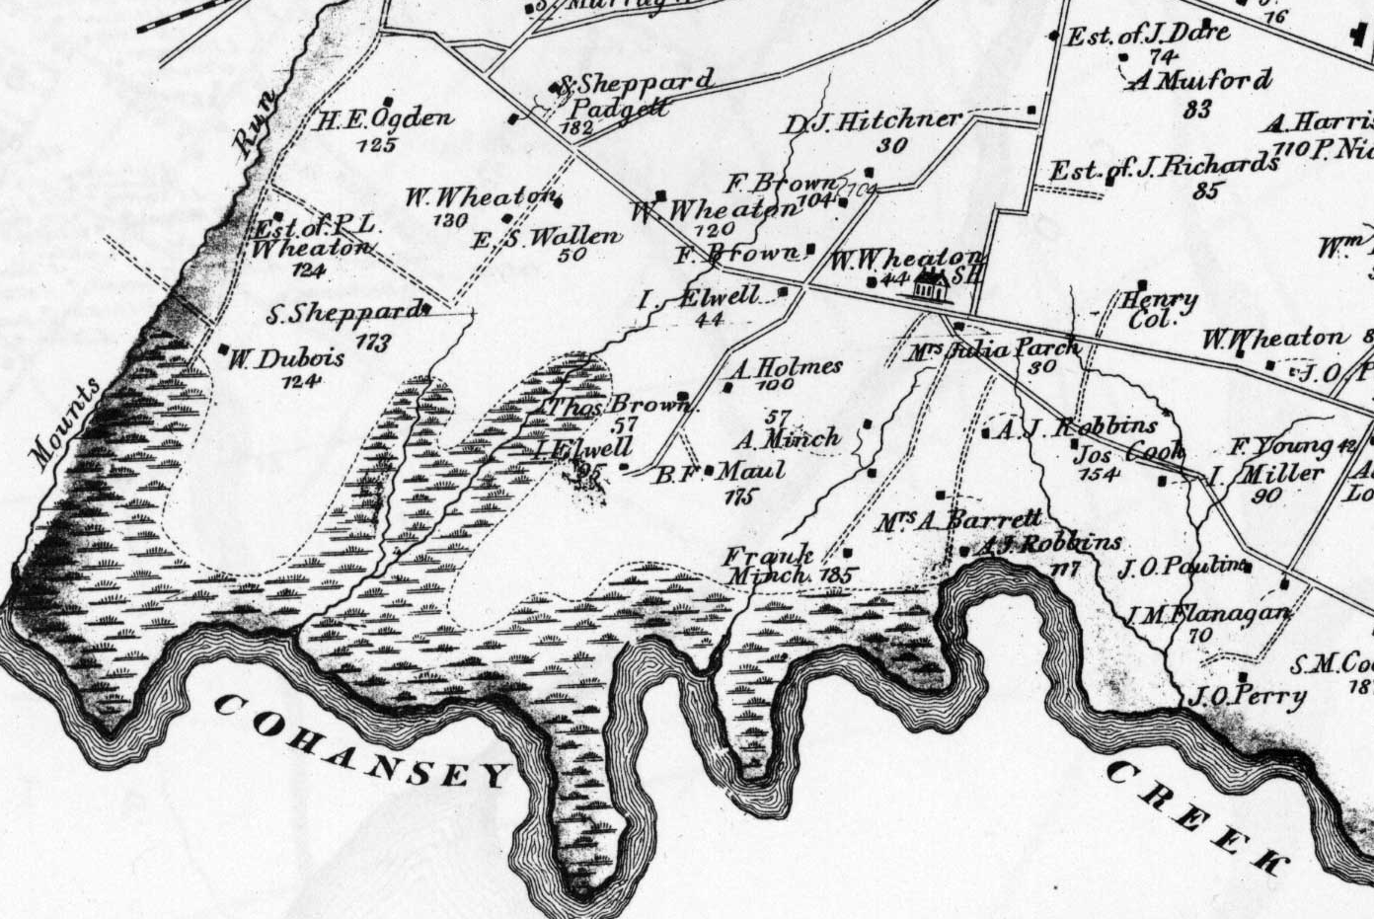

Alfred Holmes died in 1893 and while the post-mortem inventory of his personal estate was highly itemized, there was no specific mention made of outbuildings and their contents. He was buried in the Broad Street Presbyterian Church cemetery in Bridgeton.

Once again, the farm was sold at auction. The sale was advertised in the Bridgeton Evening News and only the legal metes and bounds of the two parcels (74.5 acres and 33 acres) was given with no description of the buildings on the property. Both parcels were purchased by Edward Perry (1847-1928), the son of John and Anna (nee Dennis) Perry. He was born and raised in Hopewell Township, married Anna Wheaton in 1881, and shortly thereafter purchased a 50-acre farm on Sheppard’s Mill Road in 1881. They lived there until purchasing the Holmes farm in 1893. In 1896, a short biography of him appeared in the Biographical Review of Cumberland County, New Jersey:

Edward Dennis Perry received his education in the district schools of Lower Hopewell and of Greenwich. He worked on the farm with his father until the latter’s decease, at which time, though but eighteen years old, he assumed the management of the property, which he soon afterward let. The family then became separated; and Mr. Perry worked at whatever employment he happened to find, being engaged most of the time in farming until his marriage in 1881...the following year [he] purchased fifty acres located on the road to Shepard’s mills in Lower Hopewell. He resided on and cultivated that property until the spring of 1893, when he purchased and moved on to his present farm of seventy-five acres. He has been quite successful as a farmer, and he is one of the large land-owners of the county….he served his town in the capacity of Overseer of Roads.

Edward Perry is consistently enumerated in various censuses as a farmer, living in the house with his wife as they raised their seven children. He and his wife, Anna, were charter members of the Hope Grange in Bridgeton in which they were both active. The local newspaper often noted his attendance at agricultural meetings and county fairs.

Perry died in 1928 and the farm was inherited by his wife, Anna. She is enumerated in the 1930 census as a 74-year old widow with the stated occupation as the farmer of a “general farm;” living with her is 15-year old Charles McPherson, listed as a boarder. She died in September 1935 and was buried next to husband in Overlook Cemetery, Bridgeton.

The first aerial photograph of this part of New Jersey was taken in 1931. Very blurry and in black and white, it shows a collection of buildings, presumably the house and various outbuildings, on the east side of what is today Loatman Road [fig. 6].

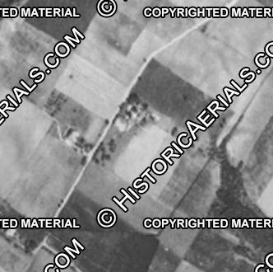

Figure 6: 1931 aerial view of the farm
[HistoricalAerials.com]

By order of the Orphan’s Court, Anna Perry’s real estate holdings were sold at public auction on November 21, 1936. The advertisement for the Perry Homestead Farm (as parcel number one was called in the ad) shows the farm then consisted of three tracts, one of 74.5 acres, one of 33 acres of meadow, and one of 17 acres. Also included in the sale were a 50-acre acre farm on Wheaton Lane (now Perry Road and on which their son, Linwood, was living), and a 13.27-acre tract in Greenwich Township. No description of any buildings was given.

Edward and Anna’s son, E. [Edward] Linwood Perry (1889-1969), purchased the farm, taking title on December 26, 1936. Perry was enumerated in the 1940 census as a 52-year old farmer, living here with his 50-year old wife, Elsie. In the 1950 census, he is cited as a 61-year old farmer living in the house with his wife. Like his parents, both were active in the Hope Grange in Bridgeton. By the early 1970s, the farm was owned by Robert Fralinger Jr., a local peach and poultry farmer.

The 1970 black and white aerial photograph taken during Fralinger’s ownership clearly shows a farmhouse to the north with three outbuildings to the south. The largest of the outbuildings is the southernmost one [circled in red in fig. 7] which is the log stable with its two shed additions.

Little is known about the house seen in the 1970 aerial. In 1975, after Robert Fralinger decided to donate the log stable to the Cumberland County Historical Society, restoration architect, G. Edwin Brumbaugh of Gwynedd Valley, Pennsylvania, visited the farmstead to examine the stable at its original location. He noted that “due north of the log structure” was the charred ruins of a house with “a few pieces of burned broad-axe hewn squared timbers” visible in the “carefully laid and roughly squared iron stone walls” of the foundation of the easternmost section. The hewn timbers suggest a construction date of ca. 1830 or earlier for the oldest part of the house suggesting it dates to the period of Holmes family ownership.

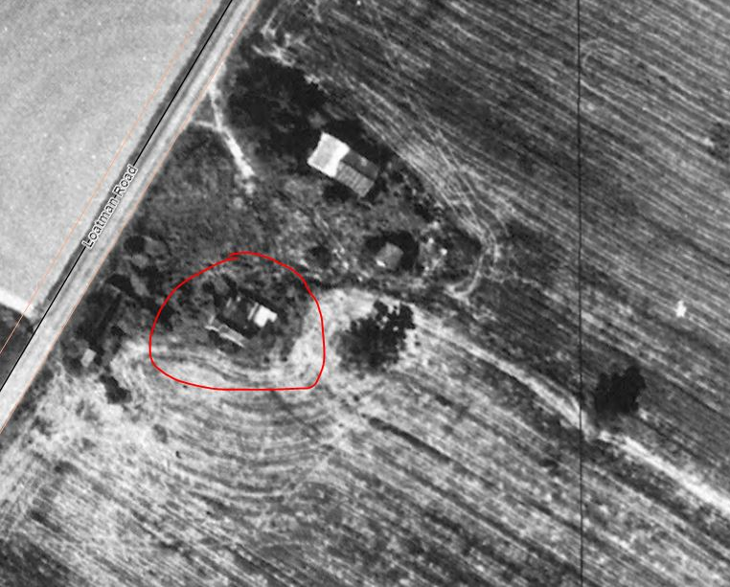

Figure 7: 1970 aerial photograph showing the farmstead with the house and three outbuildings. The log stable is circled in red. [NJ Geo-Web, 1970 Wetlands Black and White Imagery overlay]

Non-residential Log Buildings in Southern New Jersey
The exact number of non-residential log buildings erected in southern New Jersey between the late 1600s and the early 1800s will likely never be known. As mentioned in Douglass Reed’s report, a tally of the log houses in 1798 in nearby Mannington Township, Salem County revealed a little more than 10% of the total of 110 houses were of logs. Unfortunately, no similar contemporary “census” of historic non-residential log buildings exists. However, references to non-residential log structures found in early primary and secondary sources as cited below suggest they were characteristic of the early built environment in southern New Jersey but were probably not erected in large numbers. A present-day census of surviving extant historic log buildings in all of New Jersey is maintained by the Historic Preservation Office and of the 42 cited, only two are noted as outbuildings: this log stable (called the “Swedish granary” on the list) and a “log outbuilding” in Burlington County that, after further research, turned out to be originally erected as a house.

A correction to this census is the 17th-century (purported) Mortonson-Van Leer “log cabin” which is identified therein as a house. It was moved from its original location on the north side of Raccoon Creek to its present location behind the Trinity (Old Swedes) Church in Swedesboro, Gloucester County where interpretative signage identifies it as a farm outbuilding. This would appear to be corroborated by its lack of windows, dirt floor, and 11’ x 13’ size as shown on HABS drawings. Log expert Douglass Reed examined a photograph of it during this project and considers it “a second known outbuilding of unknown date and unknown original use.”

Primary and Secondary Source References Related to Non-Residential Log Buildings in Southern New Jersey
William J.S. Bradway reported in 1935 that “there is a well-founded tradition that the settlers at Carlltown [Salem County] built a log schoolhouse in 1763.” Alexander Moore ran a successful store in Cohansey Bridge (Bridgeton, Cumberland County) in the 1730s, operating out of a cedar log building. The first jail in Greenwich was built of logs, as was the first Quaker Meetinghouse (ca. 1690) there. Also built of logs were the first churches in Deerfield (1737), Back Neck (before 1709), and Fairfield (around 1700).

Of particular interest are the following 18th- and 19th-century references in newspaper advertisements for farm-related log outbuildings in both Cumberland County and in neighboring South Jersey counties. None are known to be extant, however. The underlined text is added for emphasis.

[1768] To be sold at pubic vendue…a plantation situate in Pilesgrove, Salem County…there are on the place two log houses…a log barn 28 feet by 20…

[1776] Will be sold at public vendue…in Upper Penn’s Neck in the county of Salem….whereon is a log dwelling-house, log barn, two apple orchards…

[1784] A plantation in Pilesgrove Township, Salem County “whereon is 2 log houses…a log barn…”

[1790] TO BE SOLD at Private Sale…A plantation or tract of land situate in the township of Pilesgrove, county of Salem….there are on said place a new frame dwelling-house…a log barn and stables…

[1793] TO BE SOLD…in Fairfield Township, Cumberland County…whereon is a large frame dwelling house, a smaller log house, a convenient cedar log barn…and Manaway Sawmill in the upper part of Maurice’s River Township, in Cumberland County….near it is a large cedar log dwelling house, a cedar stable…

[1803] A Plantation or Tract of Land situate in the town of Deptford, county of Gloucester...the buildings are a new log house…a new log stable large enough for three or four horses…

[1814] For Sale Cheap, A plantation or Tract of land situate in Upper Alloway Creek township, Salem county, N.J…..the House is 20 by 30 feet, and a Log Barn and an excellent Apple Orchard…

[1814] To Be Sold at Public Vendue….in the township of Maurice River [Cumberland County]…a lot containing five acres…on which is a Log Stable…

[1816] Public Sale…A House and lot of Land…the lot contains half an acre, with a two story house and kitchen, a small shop, and a cedar log stable thereon.

Summary Statement of Significance
Thus, the ca. 1783-85 log stable in Greenwich is a rare survivor of a type of construction that was never built in large numbers in southern New Jersey and appears to be one of only two known extant historic, farm-related log outbuildings still standing in the state.

https://hmvarch.org/dendro/nj-cumberland-swedishgranary-greenwich-dendro.pdf, 18. Dendrochronology is a scientific method of using weather-related variations in tree-ring growth to establish the date when a timber was harvested. It is well-explained in the link above.
Salem Deeds, Book 6, 58. The legal description cited here was stated in an abstract of the deed found in William Nelson, ed., Patents and Deeds and Other Early Records of New Jersey, 1664-1703 (Baltimore, MD: Clearfield Publishing), reprint in 1982 of the 1899 edition, 614.
Holmes Family Folder, Cumberland County Historical Society; Obediah Holmes Jr. is first mentioned as owning land in Cumberland County in a return of survey dated June 24, 1686, see Revel’s Book of Surveys (in Patents and Deeds), 115.
Will of Jonathan Holmes, NJ State Archives file #114 Q (Salem County wills).
Ancestry.com database: New Jersey, U.S., Compiled Census and Census Substitutes Index, 1643-1890.
Tombstone Inscriptions, Presbyterian Church, Greenwich, Ancestry.com database.
H. Stanley Craig, comp., Cumberland County New Jersey Genealogical Data (Merchantville, NJ: H. Stanley Craig), 83.
New Jersey State Archives, Cumberland County wills, #859F.
The New Jersey Gazette (Burlington, NJ), 2-4-1778, 10; Peter Wacker, Land and People (New Brunswick, NJ: Rutgers University Press, 1975), 416.
Orphan’s Court Records, Book A, 358.
The map is filed in a large volume labeled Index Maps of Divisions, page 59, as found in the Cumberland County Surrogate’s Office (kept in a locked metal cabinet with adoption records).
1830 census, Cumberland County, NJ, Hopewell Township, 1. Earlier federal censuses for 1790, 1810, and 1820 for New Jersey have not survived.
Thomas F. Gordon, Gazetteer of the State of New Jersey (Trenton, NJ: Daniel Fenton), 159.
1840 census, Cumberland County, NJ, Hopewell Township, 15.
John Barber and Henry Howe, Historical Collections of the State of New Jersey (New York: S. Tuttle, 1844), 146-147.
West-Jersey Pioneer (Bridgeton, NJ), 6-2-1855, 3.
Cumberland County Inventories, Book D, 30.
West-Jersey Pioneer (Bridgeton, NJ), 9-29-1855, 4.
Cumberland County Deeds, Book 88, 78.
Cumberland County, Hopewell Township, NJ, 1860 federal census, 204; West-Jersey Pioneer (Bridgeton, NJ), 6-18-1864, 3.
Cumberland County, Hopewell Township, NJ, 1870 federal census, 45; 1880 federal census, 31C.
1880 Agricultural census, Cumberland County, Hopewell Township, 23.
Cumberland County Inventories, Book J, 60.
Find-A-Grave.
Bridgeton Evening News (Bridgeton, NJ), 2-13-1895, 2.
Biographical Review of Cumberland County, New Jersey (Boston: Biographical Review Publishing Company, 1896), 399-400.
Bridgeton Evening News (Bridgeton, NJ), 11-29-1905, 7-17-1917, 7-25-1917, 9-21-1935.
1930 census, New Jersey, Hopewell Township, sheet 7-B.
Find-A-Grave, Anna Perry, Overlook Cemetery.
Bridgeton Evening News (Bridgeton, NJ), 11-7-1936, 8.
Cumberland County Deeds, book 522, 410; 1940 census, Hopewell Township, sheet 13-b [he is listed under the name of Edward L. Perry]; 1950 census, Hopewell Township, sheet 16; Press of Atlantic City, 9-22-1960, 31.
G. Edwin Brumbaugh, “Report Upon Log Structure Near Greenwich, NJ,” 9-19-1973. [Cumberland County Historical Society, Log Granary folder.]
1798 Federal Direct Tax, Mannington Township, Salem County, NJ; “Traditional Log Buildings in NJ: A Census,” updated 9-25-2014, New Jersey Historic Preservation Office [note that this list is incomplete]; Burlington County Inventory and Survey of Historic, Architectural, and Cultural Resources 1975-1977, Locust Hill Farm, Jobstown vicinity, Springfield Township, Burlington County, New Jersey.
See the HABS drawings of 1938, Vanleer Cedar Cabin, NJ-92, https://www.loc.gov/resource/hhh.nj0532.sheet/?sp=5
Email communication, Douglass Reed to James Turk, Joan Berkey, and Joe Matthews, 10-4-2023.
William J.S. Bradway, “Journeys Around Jericho,” Bridgeton Evening News, 3-2-1935; Charles Sheppard Papers, Vol. VII, 632 [on microfilm at the Cumberland County Historical Society]; Thomas Cushing and Charles Sheppard, History of the Counties of Gloucester, Salem, and Cumberland, New Jersey (Philadelphia: Everts & Peck, 1883), 506, 528, 583, 653, 682, 666.
Pennsylvania Gazette (Philadelphia, PA), 8-18-1768, 1.
Pennsylvania Gazette (Philadelphia, PA), 7-31-1776, 4.
Pennsylvania Gazette (Philadelphia, PA), 2-18-1784, 4.
Pennsylvania Gazette (Philadelphia, PA), 9-15-1790, 1
Pennsylvania Gazette (Philadelphia, PA), 1-9-1793, 3.
The Gazette of the United States (Philadelphia, PA), 9-16-1803, 2.
Trenton Federalist (Trenton, NJ), 1-31-1814, 3.
Trenton Federalist (Trenton, NJ), 3-21-1814, 4.
Washington Whig (Bridgeton, NJ), 1-29-1816, 3.

